# “GENETIC ALGORITHM BASED HEALTH INDEX

# DETERMINATION OF DISTRIBUTION TRANSFORMER*”*

*PROJECT REPORT*

*Submitted to*

# GONDWANA UNIVERSITY, GADCHIROLI

*by*

**Mr. CHANDAN YADAV ( 2018033700025224 )**

**Mr. RITIK A. DHOTE ( 2018033700025011 )**

**Mr. KERBA MUSANDE ( 2018033700025108 )**

**Mr. RAMESHWAR KALYANE (2018033700025045 )**

**Mr. CHANCHAL MOON (2018033700025101 )**

*Under the guidance of*

## Prof. T. F. More

*In partial fulfillment for the award of the degree of*

## BACHELOR OF ENGINEERING IN

**ELECTRICAL ENGINEERING**



**DEPARTMENT OF ELECTRICAL ENGINEERING**

# GOVERNMENT COLLEGE OF ENGINEERING,

## CHANDRAPUR-442403 2021-2022



CERTIFICATE

This is to certify that project report entitled **“ GENETIC ALOGRITHM BASED HEALTH INDEX DETERMINATION OF DISTRIBUTION TRANSFORMER”** is submitted by,

**Mr. CHANDAN YADAV ( 2018033700025224 )**

**Mr. RITIK A. DHOTE ( 2018033700025011 )**

**Mr. KERBA MUSANDE ( 2018033700025108 )**

**Mr. RAMESHWAR KALYANE (2018033700025045 )**

**Mr. CHANCHAL MOON (2018033700025101 )**

Students of Final year B.E. Electrical Engineering. They have completed the said work satisfactorily during the academic session 2021-22. The work is submitted in the partial fulfillment of award of the degree of Bachelor of Engineering in Electrical Engineering by Gondwana University, Gadchiroli.

Date:

Place: Chandrapur

## Guide Head of the Department

Prof. T. F. More Dr. A. P. Deshpande (Assistant Professor)

## Principal

Dr.S.G.Akojwar

# PROJECT APPROVAL SHEET

Following team has done the appropriate work related to the **“GENETICALOGRITHM BASED HEALTH INDEX DETERMINATION OF DISTRIBUTION TRANSFORMER”** in partial fulfillment for the award of Bachelor of Engineering in Instrumentation Engineering of “Gondwana University, Gadchiroli” and is being submitted to Government College of Engineering, Chandrapur.

Team:

Mr. CHANDAN YADAV ( 2018033700025224 )

Mr. RITIK A. DHOTE ( 2018033700025011 )

Mr. KERBA MUSANDE ( 2018033700025108 )

Mr. RAMESHWAR KALYANE (2018033700025045 )

Mr. CHANCHAL MOON (2018033700025101 )

## Internal Examiner:

Prof. T. F. More

## External Examiner:

(Prof. )

Date:

Place: Chandrapur

## GOVERNMENT COLLGE OF ENGINEERING, CHANDRAPUR- 442 403



**Vision of the Institute**

“To excel in technical education having focus on innovative design, entrepreneurship development, enhancing employability rate and developing environment friendly society.”

## Mission of the Institute

* To educate and train undergraduate and research students for practicingprofessionalism, ethical approach, leadership and entrepreneurship ability.
* To nurture conducive environment for learning.
* To develop proficient technocrats catering to the needs of industry, society andenvironment.
* To enhance rapport with distinguished institutes, industries and alumni for excellencein education, research, and consultancy.

## Vision of the Department of Electrical Engineering

“The department of Electrical engineering will be the centre for excellence in education, training and research that fosters entrepreneurship, employability, environment and societal development.”

## Mission of the Department of Electrical Engineering

“To impart education to undergraduate and research students for development of globally competent technical manpower for industry, entrepreneurship and sustainable growth of society”

|  |  |
| --- | --- |
| **M 1** | To educate and train students in to globally competent Electrical Engineers; |
| **M 2** | To provide excellent learning facilities for development of technical manpower through interaction with industries, R&D centers and academia; |
| **M 3** | To provide knowledge base and consultancy services to rural and tribal community around us for their uplift and well being. |



# Program Outcomes

**PO1: Engineering knowledge:** Apply the knowledge of mathematics, science, engineering fundamentals, and an engineering specialization to the solution of complex engineeringproblems.

**PO2: Problem analysis:** Identify, formulate, review research literature, and analyze complex engineering problems reaching substantiated conclusions using first principles of mathematics, natural sciences, and engineering sciences.

**PO3: Design/development of solutions:** Design solutions for complex engineering problems and design system components or processes that meet the specified needs with appropriate consideration for the public health and safety, and the cultural, societal, and environmental considerations.

**PO4: Conduct investigations of complex problems:** Use research-based knowledge and research methods including design of experiments, analysis and interpretation of data, and synthesis of the information to provide valid conclusions.

**PO5: Modern tool usage:** Create, select, and apply appropriate techniques, resources, and modern engineering and IT tools including prediction and modeling to complex engineering activities with an understanding of the limitations.

**PO6: The engineer and society:** Apply reasoning informed by the contextual knowledge to assess societal, health, safety, legal and cultural issues and the consequent responsibilities relevant to the professional engineering practice.

**PO7: Environment and sustainability:** Understand the impact of the professional engineering solutions in societal and environmental contexts, and demonstrate the knowledgeof, and need for sustainable development.

**PO8: Ethics:** Apply ethical principles and commit to professional ethics and responsibilities and norms of the engineering practice.

**PO9: Individual and team work:** Function effectively as an individual, and as a member or leader in diverse teams, and in multidisciplinary settings.

**PO10: Communication:** Communicate effectively on complex engineering activities with the engineering community and with society at large, such as, being able to comprehend and write effective reports and design documentation, make effective presentations, and give and receive clear instructions.

## Program Educational Objectives (PEOs)

**PEO 1:** Graduate Engineers to serve Electrical power industry as employee/self employment;

**PEO 2:** Graduate engineers equipped with fundamental knowledge and global competencies (PO) to solve industrial/societal problems;

**PEO 3:** Graduates will exhibit professionalism and humane;

**PEO 4:** Graduates with ability to engage in research and independent life-long learning to keep the pace with ever changing technology.

## Course Outcome (COs) of EP806 Major Project

After completing the course the student shall be able to

1. Perceive the idea and decide the objectives of project from literature survey
2. Formulate the procedure to meet the objectives
3. Implement the idea with effective leadership in prescribed schedule
4. Analyze the results and the ideas for future scope

**Prepare the effective technical document related to work carried out**

# PAGE INDEX

**SR.NO TOPIC PAGE No.**

**ABSTRACT 1**

**FIGURE INDEX 2**

1 INTRODUCTION 3

1.1 Why Health Index? 5

1.2 Parameters in Health Index Formulation 6

1.3 Problem Statement 7

1.4 Existing Method Used By Utility 7

1.5 Transformer Health Assessment Techniques 8

* 1. Health Index Calculation 9

**2 LITERATURE REVIEW 11**

**3 PROPOSED SYSTEM 15**

* 1. Block diagram 15
  2. Discription 15

3.3 Flow chart 16

3.4 Circuit diagram 17

3..5 Working 17

**4 COMPONENTS DETAILS 18**

4.1 Arduino Uno 18

4.2 Voltage Sensor Module 23

4.3 Realay 25

4.4 Lcd 27

4.5 DHT11–Temperature and Humidity Sensor 31

* 1. Diptrace Software 40

**5 ADVANTAGES & DISADVANTAGES 47**

**6 CONCLUSION 48**

**7 REFERENCE 49**

**ABSTRACT**

Distribution transformer is equipment which plays a very important role in the power distribution system. Because of the presence of the large number of transformers and various components over a wide area in power systems, the condition monitoring of health and automatic controlling of distribution transformers are important issues. This paper presents a fuzzy logic approach towards monitors as well as diagnosing the condition of distribution transformers, like load current, transformer oil and voltages. The suggested scheme will help to detect the internal fault of the distribution transformer and also diagnose the faults with the help of a defined range of parameters. On the performance of these parameters, the health of the distribution transformer is observed and decisions taken for whether to keep the distribution transformer in service or go for maintenance.

|  |  |  |
| --- | --- | --- |
|  | **FIGURE INDEX** |  |
| **FIGURE NO.** | **FIGURE** | **PAGE NO.** |
| FIG.1.1 | STRUCTURE OF THE HEATLH INDEX CALCULATION METHOD | 10 |
| FIG. 3.1 | BLOCK DIAGRAM | 15 |
| FIG.3.2 | FLOW CHART | 16 |
| FIG 3.3 | CIRCUIT DIAGRAM | 17 |
| FIG.4.1 | ARDUINO UNO | 18 |
| FIG.4.2 | VOLTAGE SENSOR MODULE | 23 |
| FIG 4.3 | RELAY | 25 |
| FIG.4.4 | LCD | 27 |
| FIG 4.5 | DHT11- TEMPERATURE AND HUMIDITY SENSOR | 31 |
| FIG.4.6 | ARDUINO IDE SOFTWARE | 34 |
| FIG. 4.7 | DIPTRACE | 43 |
|  |  |  |
|  |  |  |
|  |  |  |
|  |  |  |

**CHAPTER 1: INTRODUCTION**

In the present era of competitive market, the main aim of power distribution utilities is to provide a stable power supply at a least cost, maximum profit and extension of life span. Being a utility engineer, it is observed that failure in distribution transformers is due to oil leakage, overloading and unbalanced loading in remote rural areas. To avoid such problems proper condition monitoring of distribution transformer parameters plays an important role. Condition monitoring is the process or technique of monitoring the operational characteristics of a distribution transformer. The condition monitoring of the distribution transformer can be done in such a way that changes in the monitored operational characteristics can be used for predictive maintenance in advance to avoid any serious deterioration or breakdown. Condition monitoring systems can be used to estimate the distribution transformers health status from the remote end. The failure of these types of assets, results in the creation of a badly negative impact on the social life of electricity consumers. This also directly affects the direct and indirect cost of industrial and commercial electricity use. The proper management of such types of assets is discussed in [1] and [2]. A diagnostics and data interpretation skill has been used to develop the decision making and assets management model with the use of fuzzy logic techniques. Cost effective optimization skills, management activities, maintenance and combination of real time condition monitoring could be used for improvement in reliability of the system is described in [3]. Health index technique is a very important tool for integrating all of the current statistics of transformers. Single quantitative index which shows its total health is obtained with the use of these health index techniques. These health index techniques are used to show the long-term degradation level, to determine the health condition which is not easily possible to determine by routine inspection and to measure the transformer aging such as winding resistance and furans content. The position of any particular portion of a transformer with respect to repair is not shown by health index. Quantitative health index is described in [4] and [5]. Transformer health monitoring and providing the transformer health index which shows its total health is different from the traditional health condition monitoring system. In traditional health condition monitoring techniques, interaction between attributes have not been considered.The total health status of the power transformer is shown with the help of health condition by considering the interaction between various health condition monitoring tests for transformers are discussed in [6]. The incipient faults are under the severe fault category that may result in damage to the transformer and simulation in power system using Matlab/Simulink software for 100 MVA, 138/13.8 kV power transformer is discussed [7]. The classical DGA interpretation methods are used to examine the collected DGA results. Consumer and analysis of reasonable aspects of distribution transformers with remote condition monitoring systems is discussed in [9]. In [10], the issue of monitoring and evaluation of health status for distribution transformers with remote condition techniques is described. Detection of an inter turn fault at the initial stage in power transformers with transformer inter turn fault detection system (TIFDS) is discussed in [11]. In [12], transformer no-load and light load current harmonic analysis to detect the presence of inter turn fault at the incipient stage is discussed. In [13] probabilistic power system health index (PSHI) is discussed which describes power system health indices based on adequacy and security. Fuzzy logic approach is used in this paper to monitor the distribution transformer performance and for that, three numbers of input considered such as voltage, load current and transformer oil level whereas one number of output considered such as health index of distribution transformer which indicates the performance of distribution transformer according to changes in input parameters. The prime objective of the research work proposed in this paper is for utilization of fuzzy logic techniques for evaluation of distribution transformer health index on the basis of real time data. The actual field data is utilized for determination of health index using real measurement. consumer and analysis of reasonable aspects of distribution transformers with remote condition monitoring systems is discussed in [9]. In [10], the issue of monitoring and evaluation of health status for distribution transformers with remote condition techniques is described. Detection of an inter turn fault at the initial stage in power transformers with transformer inter turn fault detection system (TIFDS) is discussed in [11]. In [12], transformer no-load and light load current harmonic analysis to detect the presence of inter turn fault at the incipient stage is discussed. In [13] probabilistic power system health index (PSHI) is discussed which describes power system health indices based on adequacy and security. Fuzzy logic approach is used in this paper to monitor the distribution transformer performance and for that, three numbers of input considered such as voltage, load current and transformer oil level whereas one number of output considered such as health index of distribution transformer which indicates the performance of distribution transformer according to changes in input parameters. The prime objective of the research work proposed in this paper is for utilization of fuzzy logic techniques for evaluation of distribution transformer health index on the basis of real time data. The actual field data is utilized for determination of health index using real measurement.

**1.1 Why Health Index?**

Manufacturers often define the anticipated life of power transformers to be 25 to 40 years. However, some transformers in service are now approaching this age, and a number have reached 60 years old. Nonetheless, failure rates remain low, and there is little evidence that many are at, or near, the end-of-life. In the past, different concepts related to transformer life management have been introduced such as:

1. Probability of failure, risk of failure, and reliability
2. Effective age versus actual age
3. Remaining life and life consumption
4. End-of-life

In most of the analyses that have been done using these concepts, there is an attempt to model the insulation life, mainly the paper insulation. Temperature and DGA are the key factors in this modeling, and other valuable data such as routine test results, maintenance data, and the previous history of the transformer are usually neglected. The purpose of asset condition assessment in this work is to detect and quantify a long-term degradation and to provide a means of quantifying the remaining asset life. This assessment includes identifying assets that are at or near to the endof-life and assets that are at high risk of generalized failure that will require major capital expenditures to replace the assets. A composite HI is a very useful tool for representing the overall health of a complex asset. HI quantifies equipment condition based on numerous condition criteria that are related to the long-term degradation factors that cumulatively lead to an asset’s end-of-life. HI results differ from maintenance testing or condition-based diagnostics, which emphasize finding defects and deficiencies that need correction or remediation to keep the asset operating during some time period.

**1.2 Parameters in Health Index Formulation**

To assess the overall condition of a power transformer, it is necessary to include as much data as is available and suitable for a realistic assessment. The development of a condition-based H requires an assessment of the relative degree of importance of the different condition factors in determining the health of the asset. Each condition factor is discussed below.

**1.3 Problem Statement**

Distribution transformers are normally heavily loaded without frequent monitoring of their Kilo Volt Ampere (KVA) demand, operating temperature (i.e., that of the core winding and of the ambient) oil level and the moisture content developed in the transformer cooling medium, which is the oil. This results in sudden breakdown of transformers leading to loss of revenue. Again, during peak hours, field technicians and engineers travel to transformer sites to pick load amps to ensure transformers are overloaded. Modern power system requires accurate, reliable technique for detection of faults, real time data monitoring and fast response speed. The reliable operation of the power system depends upon the effective functioning of the distribution transformer. Microcontroller based system has real time data monitoring, detection of abnormal condition, fast processing speed, reduced installation cost, low maintenance cost and more flexibility.

**1.4 EXISTING METHOD USED BY UTILITY**

Distribution transformer plays vital role for distribution of electricity to end user, hence the health monitoring of these transformer is very important to maintain reliability of supply. The utility (Maharashtra State Electricity Distribution Company Limited) measures parameter like oil leakages, percentage loading, identification of low voltage pockets (location), megger results, BDV results for calculation and monitoring of health status of distribution transformer. The health status of distribution transformer was improved by proper tightening of bushing nut bolts and cleaning of dust on distribution transformer bushing.

**1.5 Transformer Health Assessment Techniques**

In order to provide information about the transformer’s state of health and detect incipient faults, the monitoring system must perform physical measurements and analyze the results in the context of given environmental conditions. Health Indices methods are practical tools to aggregate the results of multiple operating observations, field inspections, and site and laboratory testing into a single objective index that quantifies overall health. They are important for asset management because they help to identify, prioritize, and schedule required investments into capital and maintenance programs. Effective methods of monitoring the condition and health of distribution transformers could help utilities to proactively mitigate failures and degradation. The objectives of the monitoring process are to: - Determine the most appropriate measurement techniques to employ for low cost, accurate, and in-situ health monitoring of distribution service transformers - Synthesize or create methods of determining transformer health from these measurements as well as contextual or environmental data as appropriate - Implement the system for field validation. Algorithms will be implemented locally and/or centrally (on a server) to measure and analyze the operational characteristics of distribution service transformers and provide an overall health index encompassing the pertinent failure and degradation modes.

Significant deviations or rapid changes in this index or its factors could be used to predict the need for maintenance, reconfiguration, upgrade, or replacement. Ultimately, this will improve reliability and reduce the cost of electric service. It is particularly important with the advent of higher penetrations of distributed PV, electric vehicles, and other energy resources that are rapidly changing the operation of the grid and have the potential to introduce added stress to service transformers. Several studies proposed various methods of establishing health indices for power transformers from the available measurement techniques. Many of these methods can be applied to distribution transformers because the underlying working principles and key components are the same. However, the prioritization and acceptable operation range of these measurements or conditions must be carefully reassessed.

**1.6 Health Index Calculation**

Health index (HI) calculation is a useful technique, it is the most basic method that was used to create maintenance strategies for transformers [32]. This method uses the representative indexes of the transformer’s operation and statement to convert them into a quantitative index and evaluate the general condition of the transformer.

The structure of the health index calculation method is shown in Figure 2.

Health index calculation method is applied to assess the distribution transformer conditions comprehensively. The statement of the transformer is classified in a range from “perfect health” to “very poor condition”. The overall health index is presented in the following equation:

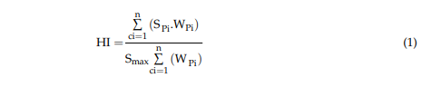

Where:

HI is the health index metric;

• SPi is the score of each assessment condition that is identified based on the measured data

• Smax is the maximum score of assessment condition

• WPi is the weight of each assessment condition;

• n is the number of the assessment condition.

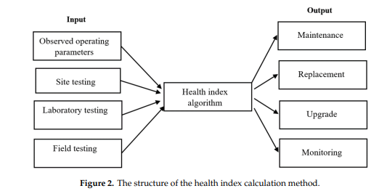

The method was tested on a 3-phase 15 kVA distribution transformer. The monitored components are dissolved gases, oil, and furan. The results showed that this method could only diagnose the general conditions of transformers. It cannot indicate exactly the type of possible faults. To identify the failure components, additional analysis is required.

**CHAPTER 2: LITERATURE REVIEW**

This section primarily aimed at reviewing related works that have been done in the area of Distribution transformers parameter monitoring as well as the theoretical review.

[1] Quynh T. Tran 1,2 , Kevin Davies 1 , Leon Roose 1 , Puthawat Wiriyakitikun 3 , Jaktupong Janjampop 3 , Eleonora Riva Sanseverino 4 and Gaetano Zizzo “he paper presented a study to determine the most significant influencing indicators on distribution transformer operation and service life. The health assessment techniques were reviewed based on up-to-date literature. This is to provide more information to transformer operators about the important parameters of distribution transformers that need to be considered. This also gives the other researchers an overview of the development process of transformer condition assessment technologies, thereby continuing to develop new effective evaluation techniques. Real-time monitoring has become a very important technology in the field of distribution transformer maintenance and has attracted more and more attention worldwide, especially with high penetration of PV systems in the distribution power grid. The potential functions of failure prediction, defection identification, and life estimation bring a series of advantages for utility companies: reducing maintenance cost, lengthening the transformer’s life, enhancing the safety of operators, minimizing accidents and the severity of destruction, as well as improving power quality. Due to these benefits and the pressure utilizing the existing assets under a competitive environment, real-time monitoring is now a hot topic to power system managers and engineers as well as researchers. Research in recent years clearly shows that advanced signal processing techniques and artificial intelligence techniques are indispensable in developing novel real-time monitoring systems. Benefiting from the development of computer techniques and communication techniques, signal processing and AI have become the most powerful tools to make next-generation real-time monitoring equipped

with high levels of sensitivity, reliability, intelligence, and cheapness.

[2] Yogendra Sunil Tamhankar1 , Arun Ghanshyam Nishad2 , Sanket Anil More3 , Priyanka Kothoke 4”The IOT based monitoring of distribution transformer is quite useful as compared to manual monitoring and also it is reliable as it is not possible to monitor always the oil level, ambient temperature rise ,load current manuallyAfter receiving of message of any abnormality we can take action immediately to prevent any catastrophic failures of distribution transformers. In a distribution network there are many distribution transformers and associating each transformer with such system, we can easily figure out that which 42 transformer is undergoing fault from the message sent to mobile. We need not have to check all transformers and corresponding phase currents and voltages and thus we can recover the system in less time. The time for receiving messages may vary due to the public GSM network traffic but still then it is effective than manual monitoring.

[3] Gajanan C. Jaiswal Health index based condition monitoring of distribution transformers with the use of fuzzy set theory is presented in the research work. Distribution transformer health dependent parameter like voltage, load current and oil level are considered as inputs for fuzzy logic model for calculation of distribution transformer health index. Twelve numbers of expert rules and two types of membership functions are utilized for mapping the three input values into output decisions to produced accurate health index of transformer. The method used in this research work is tested by using field data for 15 number of sample working distribution transformers. Results obtained were compared with the observed results from utility data. The comparison of these result shows that 80% of the results are matched. The method used by utility is based on observation of field data while the method mentioned in this paper is based on membership functions and hence more fruitful. The rules used for the calculation are easy and clear for utilization to the user. As compared with the method used by utility for data observation, the presented method can be used directly by utilities and industries in order to find out the health indices of distribution transformers, which is significant advantage.

[4] Ali Naderian Jahromi, Ray Piercy, Stephen Cress, Jim R. R. Service, and Wang Fan The composite HI presented is a very useful tool for representing the overall health of a complex asset such as a power transformer. HI quantifies equipment condition based on numerous condition criteria that are related to long-term degradation factors that cumulatively lead to a power transformer’s end-of-life. The method’s multi-criteria analysis approach combines the various factors are combined into a condition-based HI. In addition to the regular test data that have been used in the past, a count of corrective maintenance work orders can be used to evaluate the physical health condition of transformers. Some of the important factors include bushing condition, oil leak, tank corrosion, cooling system, infrared thermography, grounding, and foundation. The relation between HI and probability of failure was developed based on available data and can be applied to similar analysis applications. HI can effectively be employed to provide justification for a capital plan which includes end-of-life asset replacement.

[5] Anthony Kwarteng1 , Stephen Kwaku Okrah2 , Ben Asante2 , Patrick Amanor Bediako3 , Phin Aquesi Adom Baidoo3 The main goal of the project is to design and construct an Internet of Things Transformer Monitoring System which can display real time state in the transformer. After the construction of the device, the system was tested successfully. That is the device can monitor the condition of the transformer and send data accumulated from the sensors through the Wi-Fi and displayed over the IoT platform. All parameters that are critical and needed and have exceeded their threshold can be sent through SMS for immediate action to be taken. Even though the construction of the system was successful, there were some challenges. The general use of prefabricated microcontrollers for such a project that

require specific features increases the complexity and number of hardware modules to be used to execute a simple desire.

**Chapter 3: Proposed System**

**3.1 BLOCK DIAGRAM**

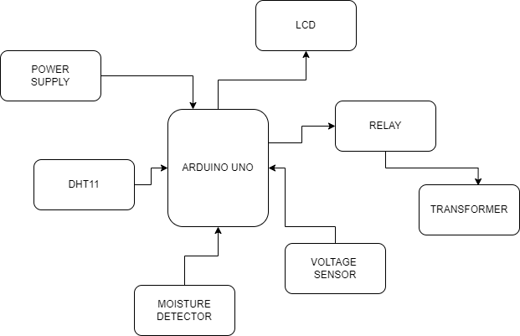

**3.2 DESCRIPTION**

In this project we use the Arduino uno as a microcontroller. DHT 11 moisture sensor and voltage sensor are the input device which is connected to arduino uno for input. The Relay and LCD are used as an output device which is connected to a microcontroller. The transformer is attached to a relay as an output device.

**3.3 FLOW CHART**

Voltage >13

DHT>36

Moisture >500

Relay off

LCD

Error onward print

Relay on

LCD print voltage temperature ,humidity, moisture level

End

**3.4 CIRCUIT DIAGRAM**

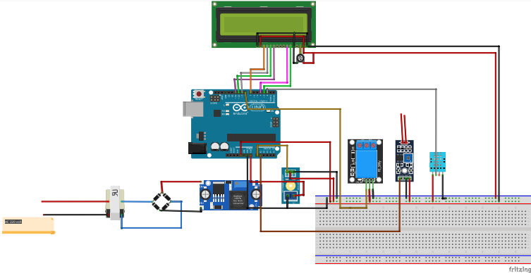

**3.5 Working**

In this project we used an arduino uno microcontroller. When we start the project microcontroller and other module systems will be on. A voltage sensor is used to measure voltage sensors and will detect temperature. There are two probes connected to the Op-amp circuit to detect oil level of the transformer. Which acts as a moisture sensor, this sensor sends data. To microcontrollers which limit set in the system already. If voltage, temperature & oil level exceeds the limit which is shown on LCD, it will damage the transformer so that the transformer automatically trips off.

**Chapter 4: Component Details**

**4.1 ARDUINO UNO**

**Arduino Uno Pinout**

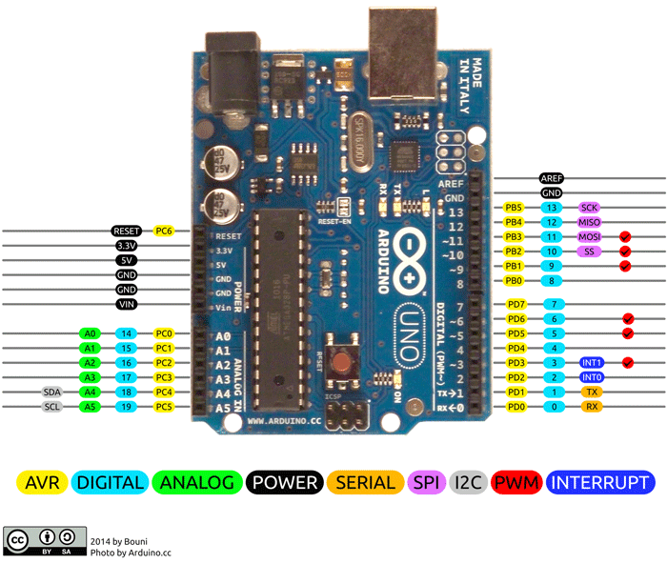

**Arduino Uno** is a popular microcontroller development board based on 8-bit [ATmega328P](https://components101.com/microcontrollers/atmega328p-pinout-features-datasheet) microcontroller. Along with ATmega328P MCU IC, it consists other components such as crystal oscillator, serial communication, voltage regulator, etc. to support the microcontroller.

**Arduino Uno Pinout Configuration**

|  |  |  |
| --- | --- | --- |
| **Pin Category** | **Pin Name** | **Details** |
| Power | Vin, 3.3V, 5V, GND | Vin: Input voltage to Arduino when using an external power source.  5V: Regulated power supply used to power microcontroller and other components on the board.  3.3V: 3.3V supply generated by on-board voltage regulator. Maximum current draw is 50mA.  GND: ground pins. |
| Reset | Reset | Resets the microcontroller. |
| Analog Pins | A0 – A5 | Used to provide analog input in the range of 0-5V |
| Input/Output Pins | Digital Pins 0 - 13 | Can be used as input or output pins. |
| Serial | 0(Rx), 1(Tx) | Used to receive and transmit TTL serial data. |
| External Interrupts | 2, 3 | To trigger an interrupt. |
| PWM | 3, 5, 6, 9, 11 | Provides 8-bit PWM output. |
| SPI | 10 (SS), 11 (MOSI), 12 (MISO) and 13 (SCK) | Used for SPI communication. |
| Inbuilt LED | 13 | To turn on the inbuilt LED. |
| TWI | A4 (SDA), A5 (SCA) | Used for TWI communication. |
| AREF | AREF | To provide reference voltage for input voltage. |

**Arduino Uno Technical Specifications**

|  |  |
| --- | --- |
| Microcontroller | ATmega328P – 8 bit AVR family microcontroller |
| Operating Voltage | 5V |
| Recommended Input Voltage | 7-12V |
| Input Voltage Limits | 6-20V |
| Analog Input Pins | 6 (A0 – A5) |
| Digital I/O Pins | 14 (Out of which 6 provide PWM output) |
| DC Current on I/O Pins | 40 mA |
| DC Current on 3.3V Pin | 50 mA |
| Flash Memory | 32 KB (0.5 KB is used for Bootloader) |
| SRAM | 2 KB |
| EEPROM | 1 KB |
| Frequency (Clock Speed) | 16 MHz |

# 

# 4.2 VOLTAGE SENSOR MODULE

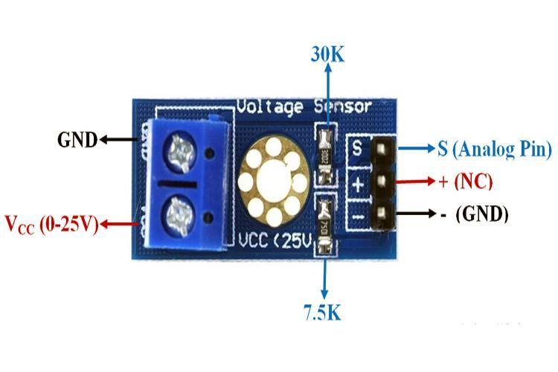

**Voltage Sensor Module**

* **Voltage Sensor** is a precise low-cost sensor for measuring voltage. It is based on the principle of resistive voltage divider design. It can make the red terminal connector input voltage to 5 times smaller.

Voltage Sensor Module Pinout Configuration

|  |  |
| --- | --- |
| **Pin Name** | **Description** |
| VCC | Positive terminal of the External voltage source (0-25V) |
| GND | Negative terminal of the External voltage source |
| S | Analog pin connected to Analog pin of Arduino |
| + | Not Connected |
| - | Ground Pin connected to GND of Arduino |

**Voltage Detection Sensor Module Features & Specifications**

* Input Voltage: 0 to 25V
* Voltage Detection Range: 0.02445 to 25
* Analog Voltage Resolution: 0.00489V
* Needs no external components
* Easy to use with Microcontrollers
* Small, cheap and easily available
* Dimensions: 4 × 3 × 2 cm

**4.3 RELAY**

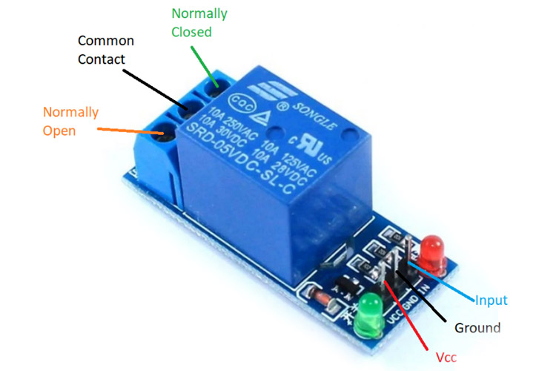

Relay is an electromechanical device that uses an electric current to open or close the contacts of a switch. The single-channel relay module is much more than just a plain relay, it comprises of components that make switching and connection easier and act as indicators to show if the module is powered and if the relay is active or not.

### Single-Channel Relay Module Pin Description

|  |  |  |
| --- | --- | --- |
| **Pin Number** | **Pin Name** | **Description** |
| 1 | Relay Trigger | Input to activate the relay |
| 2 | Ground | 0V reference |
| 3 | VCC | Supply input for powering the relay coil |
| 4 | Normally Open | Normally open terminal of the relay |
| 5 | Common | Common terminal of the relay |
| 6 | Normally Closed | Normally closed contact of the relay |

### Single-Channel Relay Module Specifications

* Supply voltage – 3.75V to 6V
* Quiescent current: 2mA
* Current when the relay is active: ~70mA
* Relay maximum contact voltage – 250VAC or 30VDC
* Relay maximum current – 10A

**4.4 LCD**

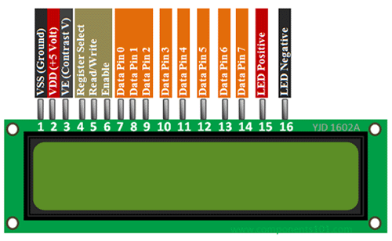

16x2 LCD modules are very commonly used in most embedded projects, the reason being its cheap price, availability, programmer friendly and available educational resources.

**16x2 LCD Pinout Configuration**

|  |  |  |
| --- | --- | --- |
| **Pin No:** | **Pin Name:** | **Description** |
| 1 | Vss (Ground) | Ground pin connected to system ground |
| 2 | Vdd (+5 Volt) | Powers the LCD with +5V (4.7V – 5.3V) |
| 3 | VE (Contrast V) | Decides the contrast level of display. Grounded to get maximum contrast. |
| 4 | Register Select | Connected to Microcontroller to shift between command/data register |
| 5 | Read/Write | Used to read or write data. Normally grounded to write data to LCD |
| 6 | Enable | Connected to Microcontroller Pin and toggled between 1 and 0 for data acknowledgement |
| 7 | Data Pin 0 | Data pins 0 to 7 forms a 8-bit data line. They can be connected to Microcontroller to send 8-bit data.  These LCD’s can also operate on 4-bit mode in such case Data pin 4,5,6 and 7 will be left free. |
| 8 | Data Pin 1 |  |
| 9 | Data Pin 2 |  |
| 10 | Data Pin 3 |  |
| 11 | Data Pin 4 |  |
| 12 | Data Pin 5 |  |
| 13 | Data Pin 6 |  |
| 14 | Data Pin 7 |  |
| 15 | LED Positive | Backlight LED pin positive terminal |
| 16 | LED Negative | Backlight LED pin negative terminal |

### HD44780 LCD Features and Technical Specifications

* Operating Voltage is 4.7V to 5.3V
* Current consumption is 1mA without backlight
* Alphanumeric LCD display module, meaning can display alphabets and numbers
* Consists of two rows and each row can print 16 characters.
* Each character is build by a 5×8 pixel box
* Can work on both 8-bit and 4-bit mode
* It can also display any custom generated characters

**4.5 DHT11–TEMPERATURE AND HUMIDITY SENSOR**

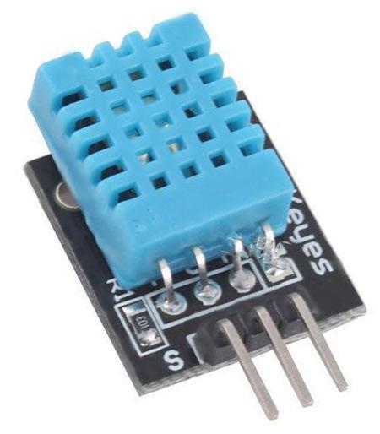

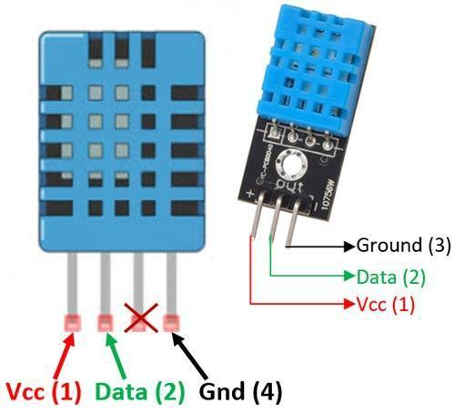

* **DHT11–Temperature and Humidity Sensor**

**DHT11 Sensor Pinout**

The **DHT11** is a commonly used **Temperature and humidity sensor that** comes with a dedicated NTC to measure temperature and an 8-bit microcontroller to output the values of temperature and humidity as serial data.

**DHT11 Pinout Identification and Configuration**:

|  |  |  |
| --- | --- | --- |
| **No:** | **Pin Name** | **Description** |
| **For DHT11 Sensor** | | |
| 1 | Vcc | Power supply 3.5V to 5.5V |
| 2 | Data | Outputs both Temperature and Humidity through serial Data |
| 3 | NC | No Connection and hence not used |
| 4 | Ground | Connected to the ground of the circuit |
| **For DHT11 Sensor module** | | |
| 1 | Vcc | Power supply 3.5V to 5.5V |
| 2 | Data | Outputs both Temperature and Humidity through serial Data |
| 3 | Ground | Connected to the ground of the circuit |

### DHT11 Specifications:

* Operating Voltage: 3.5V to 5.5V
* Operating current: 0.3mA (measuring) 60uA (standby)
* Output: Serial data
* Temperature Range: 0°C to 50°C
* Humidity Range: 20% to 90%
* Resolution: Temperature and Humidity both are 16-bit
* Accuracy: ±1°C and ±1%

**ARDUINO IDE SOFTWARE INTRO**

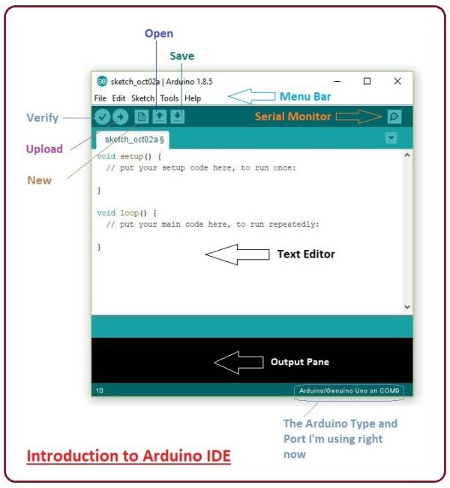

An official software introduced by [Arduino.c](https://www.arduino.cc/)c,that is mainly used for writing, compiling and uploading the code in almost all Arduino modules/boards. Arduino IDE is open-source software and is easily available to download & install.

* **Arduino IDE** is an open-source software, designed by Arduino.cc and mainly used for writing, compiling & uploading code to almost all Arduino Modules.
* It is an official Arduino software, making code compilation too easy that even a common person with no prior technical knowledge can get their feet wet with the learning process.
* It is available for all operating systems i.e. MAC, Windows, Linux and runs on the Java Platform that comes with inbuilt functions and commands that play a vital role in debugging, editing and compiling the code.
* A range of Arduino modules available including Arduino Uno, Arduino Mega, Arduino Leonardo, [Arduino Micro](https://www.theengineeringprojects.com/2018/09/introduction-to-arduino-micro.html) and many more.
* Each of them contains a microcontroller on the board that is actually programmed and accepts the information in the form of code.
* The main code, also known as a sketch, created on the IDE platform will ultimately generate a Hex File which is then transferred and uploaded in the controller on the board.
* The IDE environment mainly contains two basic parts: Editor and Compiler where the former is used for writing the required code and later is used for compiling and uploading the code into the given Arduino Module.
* This environment supports both C and C++ languages.

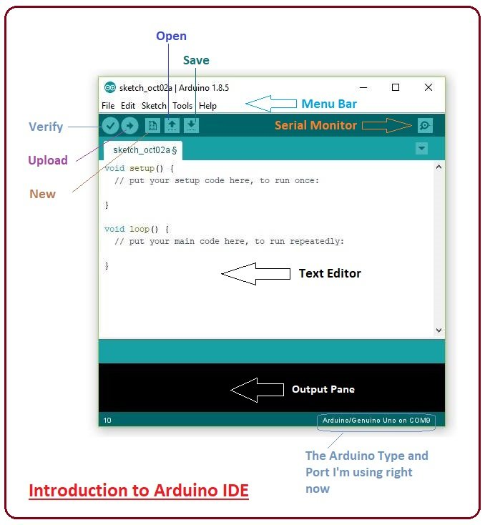

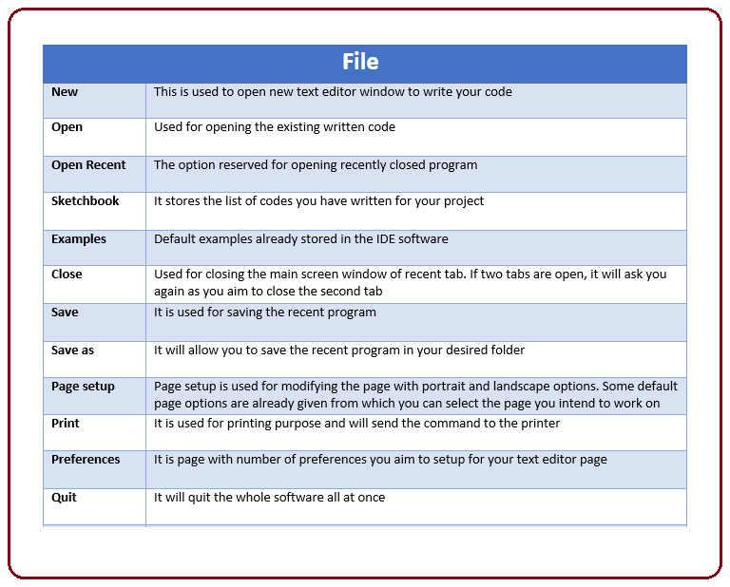

* As you go to the preference section and check the compilation section, the Output Pane will show the code compilation as you click the upload button.

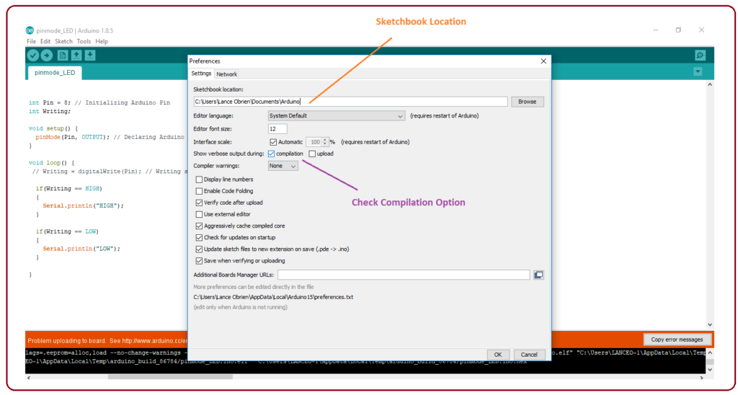

* And at the end of the compilation, it will show you the hex file it has generated for the recent sketch that will send to the Arduino Board for the specific task you aim to achieve.

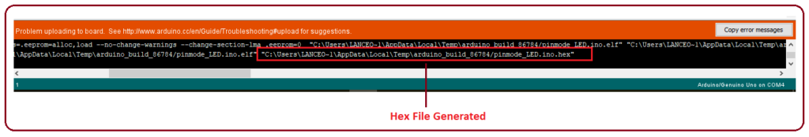

* **Edit** – Used for copying and pasting the code with further modification for font
* **Sketch** – For compiling and programming
* **Tools** – Mainly used for testing projects. The Programmer section in this panel is used for burning a bootloader to the new microcontroller.
* **Help** – In case you are feeling skeptical about software, complete help is available from getting started to troubleshooting.
* The **Six Buttons** appearing under the Menu tab are connected with the
* running program as follows.

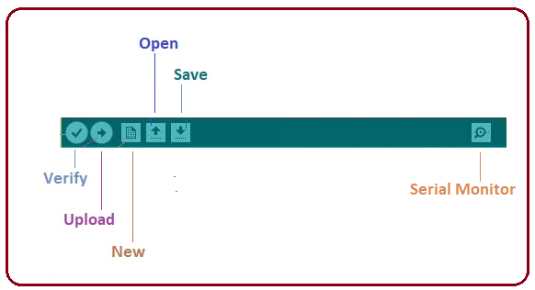

* The checkmark appearing in the circular button is used to verify the code. Click this once you have written your code.
* The arrow key will upload and transfer the required code to the Arduino board.
* The dotted paper is used for creating a new file.
* The upward arrow is reserved for opening an existing Arduino project.
* The downward arrow is used to save the current running code.
* The button appearing on the top right corner is a **Serial Monitor** – A separate pop-up window that acts as an independent terminal and plays a vital role in sending and receiving the Serial Data. You can also go to the Tools panel and select Serial Monitor, or pressing Ctrl+Shift+M all at once will open it instantly. The Serial Monitor will actually help to debug the written Sketches where you can get a hold of how your program is operating. Your Arduino Module should be connected to your computer by USB cable in order to activate the Serial Monitor.
* You need to select the baud rate of the Arduino Board you are using right now. For my Arduino Uno Baud Rate is 9600, as you write the following code and click the Serial Monitor, the output will show as the image below.

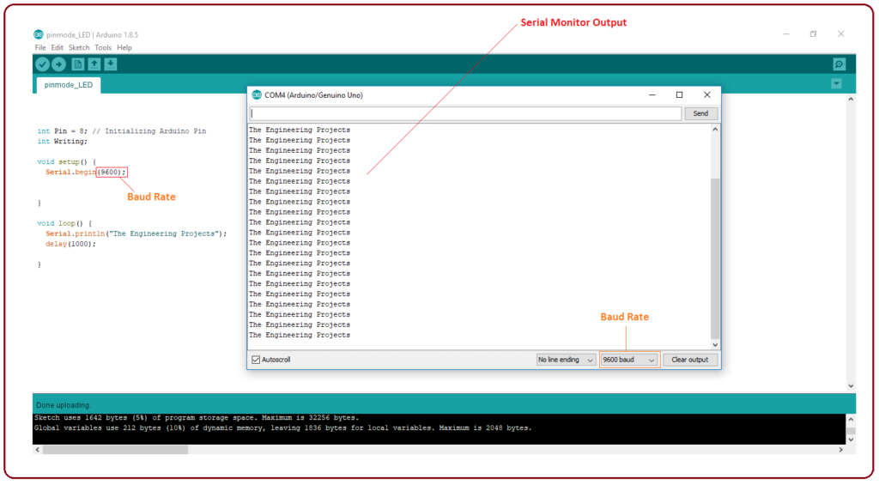

**4.6 DIPTRACE**

DipTrace is comprehensive PCB Design system. It provides the following features:

**Easy-to-learn user interface —** no need for extensive learning. DipTrace interface is intuitive, unified and easy-to-use. To design a schematic simply select and place components on the schematic and connect them together using wire and bus tools. Multi-sheet design is supported. Software modules are tightly connected. To convert schematic to PCB Layout, just select "Convert to PCB". Project can be updated from Schematic in a few clicks at any moment. When you create or edit design objects, they are highlighted to improve your work, hot keys are available. Step-by-step tutorial guides you through the design process and allows to get started with ease.

**Easy-to-use manual and powerful automatic routing —** DipTrace PCB software includes 2 automatic routers, which are able to route complex multi-layer boards as well as simple single-layer layouts. Intelligent manual routing tools allow you to create and edit traces by 90, 45, 30, 15 degree angles, or without any limitations. Routing segments, modes, highlight options and verifications are really useful. Through, blind or buried vias can be used in automatic and manual routing. Board size is unlimited.

**Multi-sheet and multi-level hierarchical circuit —** DipTrace Schematic module features multi-sheet and multi-level hierarchical structure. These features allows for easy and convenient design. Each sheet of the schematic can be converted to hierarchy block. Blocks can be inserted into main sheet and into each other as many times as needed. Placement and routing of one block can be easily applied to another block directly on the board.

**Smart project structure —** user can create and adjust layers, Net classes, Via styles, Class-to-Class Rules, different templates and design rules. This allows for smart management not only inside one project but for different-type projects as well.

**Shape-based copper pour —** powerful copper pour system can help to provide low-impedance connection and reduce manufacturing costs by minimizing the amount of etching solution required. All you have to do is to add a copper area to your board in the PCB Layout module and any unconnected pad or trace inside selected area will be automatically surrounded with a gap of the desired size. With copper pour you can also create planes and connect them to pads and vias (different thermal types are supported). Several copper polygons can be placed in one layer with user-defined pour priority.

**Smart placement and auto-placement features —** after converting Schematic to PCB layout place board outline and arrange components. Then use "Placement by list" for chips/connectors and autoplacement for other components to get acceptable result in a few minutes and start routing

**Advanced verification features —** Schematic and PCB design modules have number of verification features that help to control project accuracy on different design stages: ERC function in Schematic shows possible errors in pin connections using defined rules and allows you to correct errors step-bystep. DRC function in PCB Layout module checks clearance between design objects, minimum size of tracks and drills. Errors are displayed graphically. Real-time DRC mode is available. Real-Time DRC verifies every user action and shows errors before actually making them. You can fix errors step-by-step and rerun DRC in one click after corrections. Net Connectivity Check verifies if all nets of the PCB are electrically connected. This feature uses traces, copper pour filled area and shapes to control connectivity and reports broken and merged nets with area details. Comparing to Schematic allows you to check if routed PCB is identical to schematic.

**Real-time 3D PCB preview & Export —** 3D preview module allows to rotate your board in three axes, zoom in and out in real time and adjust color settings of the preview. DipTrace supports .vrml and .3ds models. More than 2,500 3D models are already included for free. VRML 2.0 export available.

**Spice Support —** with DipTrace Schematic Capture or Component Editor specify Spice settings or attach models to the parts. Then export *.cir netlist of your Schematic to LT Spice or another simulation software to verify how it works.

**Import/Export features —** package software modules allows you to exchange schematics, layouts and libraries with other EDA and CAD applications: DXF, Eagle, P-CAD, PADS and OrCAD. Accel, Allegro, Mentor, PADS, P-CAD, OrCAD, Protel and Tango netlist formats are supported.

**Manufacturing output formats —** DipTrace exports number of different manufacturing output formats. Using this PCB software, you can produce Excellon N/C Drill files for numerically controlled (N.C.) drilling machines and RS-274X Gerber files for sending to board manufacturers. Vectorizing function allows to export TrueType fonts and raster images. DXF output is supported as well.

**Producing boards with milling method —** DipTrace allows to export edge polylines to DXF format. The DXF files can be converted to G-code with Ace Converter (it's Free). Before edge exporting DRC checks design once again and shows possible problems, if some exist.

**Standard component libraries —** DipTrace package includes component and pattern libraries with 100.000+ components from different manufacturers.

**Creation of your own libraries —** Component and Pattern Editors allow to design symbols and patterns. To create complete component simply connect them together, using Component Editor. This version of training has been created for DipTrace ver. 2.3, but almost everything mentioned below should be appropriate for other versions. Remember, that older version might not have all features, that we discuss during this course

**Advanced verification features —** Schematic and PCB design modules have number of verification features that help to control project accuracy on different design stages: ERC function in Schematic shows possible errors in pin connections using defined rules and allows you to correct errors step-bystep. DRC function in PCB Layout module checks clearance between design objects, minimum size of tracks and drills. Errors are displayed graphically. Real-time DRC mode is available. Real-Time DRC verifies every user action and shows errors before actually making them. You can fix errors step-by-step and rerun DRC in one click after corrections. Net Connectivity Check verifies if all nets of the PCB are electrically connected. This feature uses traces, copper pour filled area and shapes to control connectivity and reports broken and merged nets with area details. Comparing to Schematic allows you to check if routed PCB is identical to schematic.

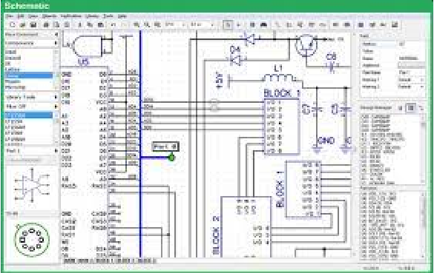

**Real-time 3D PCB preview & Export —** 3D preview module allows to rotate your board in three axes, zoom in and out in real time and adjust color settings of the preview. DipTrace supports .vrml and .3ds models. More than 2,500 3D models are already included for free. VRML 2.0 export available.

**Spice Support —** with DipTrace Schematic Capture or Component Editor specify Spice settings or attach models to the parts. Then export *.cir netlist of your Schematic to LT Spice or another simulation software to verify how it works.

**Import/Export features —** package software modules allows you to exchange schematics, layouts and libraries with other EDA and CAD applications: DXF, Eagle, P-CAD, PADS and OrCAD. Accel, Allegro, Mentor, PADS, P-CAD, OrCAD, Protel and Tango netlist formats are supported.

**Manufacturing output formats —** DipTrace exports number of different manufacturing output formats. Using this PCB software, you can produce Excellon N/C Drill files for numerically controlled (N.C.) drilling machines and RS-274X Gerber files for sending to board manufacturers. Vectorizing function allows to export TrueType fonts and raster images. DXF output is supported as well.

**Producing boards with milling method —** DipTrace allows to export edge polylines to DXF format. The DXF files can be converted to G-code with Ace Converter (it's Free). Before edge exporting DRC checks design once again and shows possible problems, if some exist.

**Standard component libraries —** DipTrace package includes component and pattern libraries with 100.000+ components from different manufacturers.

**Creation of your own libraries —** Component and Pattern Editors allow to design symbols and patterns. To create complete component simply connect them together, using Component Editor. This version of training has been created for DipTrace ver. 2.3, but almost everything mentioned below should be appropriate for other versions. Remember, that older version might not have all features, that we discuss during this course

**INSTALLATION**

**Minimum system requirements for DipTrace: -**

OS Windows 2000/XP, Vista, Win7/Win8 (both 32-bit and 64-bit versions are supported), Linux with Wine or MacOS X Leopard or newer. - Processor Pentium III / Athlon XP - 256Mb RAM - 500Mb free space on hard drive - monitor with 1024x768 resolution, 8Mb video RAM.

**Recommend system requirements of DipTrace: -** OS Windows 2000/XP, Vista, Win7/Win8 (both 32-bit and 64-bit versions are supported), Linux with Wine or MacOSX Leopard or newer - Processor Pentium IV / Athlon 64 or high - 1 Gb RAM or more - 1,5 Gb free space on hard drive - monitor with 1280x1024 resolution or higher, graphic card with OpenGL and DirectX 9.0 support or higher, 128Mb video RAM Install wizard offers "C:/Program Files/DipTrace" as default installation folder or Program Files (x86) for 32-bit applications on 64-bit operating systems, but you can install DipTrace in any other folder. You should have administrator rights. We also recommend to turn OFF antivirus software and firewall, as some can try to block DipTrace installation. If you have a previous version of DipTrace installed with user libraries and projects in standard DipTrace folder, we recommend to backup these files first. Then delete current version and run install wizard of the new version. Notice that if you have added patterns and components to standard libraries — they will be lost, because libraries are renewed with installation of the new version. That's why always save modified libraries, before updating the software product. For your convenience, we recommend to save user's patterns and components in the separate libraries and don't modify standard ones. For more information read DipTrace Installation Guide, available at our web-site.

**CHAPTER 5: ADVANTAGES & DISADVANTAGES**

**ADVANTAGES**

1. Reliable.
2. Can work with small number of samples.
3. The weights can be regulated depending on the assets under investigation.

**DISADVANTAGES**

1. The accuracy depends heavily on weighted parameters.
2. The condition monitoring may costly and the results only reflect the preferences of the human-expert.
3. Low accuracy for the systems and devices are controlled linguistically, or have a contradictory condition.

**CHAPTER 6: CONCLUSION**

Real-time monitoring has become a very important technology in the field of distribution transformer maintenance and has attracted more and more attention worldwide, especially with high penetration of PV systems in the distribution power grid. The potential functions of failure prediction, defection identification, and life estimation bring a series of advantages for utility companies: reducing maintenance cost, lengthening the transformer’s life, enhancing the safety of operators, minimizing accidents and the severity of destruction, as well as improving power quality. Due to these benefits and the pressure utilizing the existing assets under a competitive environment, real-time monitoring is now a hot topic to power system managers and engineers as well as researchers.

**CHAPTER 7 : REFERENCES**

1. Quynh T. Tran 1,2 , Kevin Davies 1 , Leon Roose 1 , Puthawat Wiriyakitikun 3 , Jaktupong Janjampop 3 , Eleonora Riva Sanseverino 4 and Gaetano Zizzo 4 “A Review of Health Assessment Techniques for Distribution Transformers in Smart Distribution Grids”Published: 16 November 2020
2. Yogendra Sunil Tamhankar1 , Arun Ghanshyam Nishad2 , Sanket Anil More 3,Priyanka Kothoke 4 “Transformer Health Monitoring by using Sensor”International Journal of Innovative Research in Science, Engineering and Technology (IJIRSET)||Volume 9, Issue 4, April 2020||
3. Gajanan C. Jaiswal Health Index Based Condition Monitoring of Distribution Transformer” 978-1-4673-8888-7/16/$31.00 ©2016 IEEE.
4. Ali Naderian Jahromi, Ray Piercy, Stephen Cress, Jim R. R. Service, and Wang Fan An Approach to Power Transformer Asset Management Using Health Index IEEE Electrical Insulation Magazine.
5. Anthony Kwarteng1 , Stephen Kwaku Okrah2 , Ben Asante2 , Patrick Amanor Bediako3 , Phin Aquesi Adom Baidoo3 “ Design and Construction of an IoT Based Distribution Transformer Condition Monitoring System The International Journal of Engineering and Science (IJES) || Volume 2021

[6] M. Wang, A. J. Vandermaar, and K. D. Srivastava, “Review of condition assessment of power transformers in service,” IEEE Elect. Insul. Mag., vol. 18, pp. 12-25, Nov./ Dec. 2018

[7] A. E. B. Abu-Elanien and M. M. A. Salama, “Asset management techniques for transformers,” Elect. Power Syst. Res. J., vol. 80, pp. 456-464, April 2018

[8] Muhammad Arshad, Syed M. Islam, A. Khaliq, “Fuzzy logic approach in power transformers management and decision making,” IEEE Transactions on Dielectrics and Electrical Insulation, vol. 21, pp. 2343- 2354, 2018.

[9] A. Jahromi, R, Piercy, S. Cress, J. Service and W. Fan, “An approach to power transformer asset management using health index,” IEEE Elect. Insul. Mag., vol. 25, pp. 20-34, Mar./Apr. 2020.

[10] A. Naderian, S. Cress, R. Piercy, F. Wang, and J. Service, “An approach to determine the health index of power transformers,” in Proc. Conf. Rec. IEEE Int. Symp. Elect. Insul., pp. 192-196, Jun. 2018.

[11] J. Singh, Y. R. Sood, and R. K. Jarial, “Condition monitoring of power transformers-bibliography survey,” IEEE Elect. Insul. Mag., vol. 24, pp. 11-25, May/Jun. 2020

[12] K. Ramesh and M. Sushama, “Inter-turn fault detection in power transformer using fuzzy logic,” Science Engineering and Management Research(ICSEMR), 2014, International conference, pp. 1-5, 2018.

[13] A. Abu-Siada, s. Hmood and S. Islam, “A new fuzzy logic approach for consistent interpretation of dissolved gas-in-oil analysis,” IEEE Transcations on Dielectrics and Electrical Insulation, vol. 20, pp. 2343- 2349, 2017.

[14] A. Avinash Nelson, Gajanan C. Jaiswal, Makarand S. Ballal, “Economical aspects of remote condition monitoring system for distribution transformer,” Power, Automation and Communication (INPAC), 2018 International conference, pp. 45-49, Oct. 2018.

**[15] A. Avinash Nelson, Gajanan C. Jaiswal, Makarand S. Ballal, D.R. Tutakne,“Remote condition monitoring system for distribution transformer,” 2018 Power System Conference (NPSC), pp. 1-5, Dec. 2018.**